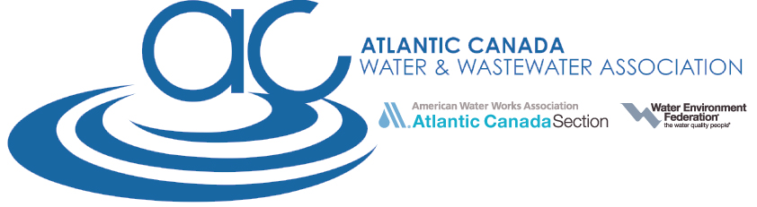

ACWWA Taste Test Entry Form

Event Date: Tuesday, October 8th, 2019 at 9:30 AM
Location: Halifax Marriott Harbourfront Hotel

Entry forms must be received by Friday, September 27, 2019. Water samples will be accepted at the Registration Desk during Registration hours. All samples must be received PRIOR TO Monday, October 7th, 2019 at 3 PM. Two samples should be collected, each in a 1-liter container. While you can use any type of container, the suggested use is a glass, Teflon-capped container with no air at the top and a small opening for easy pouring. Each container should clearly identify the name of the water system. A representative of the water system must be present at the conference for eligibility in the competition.

Official Water System Name:
Water System Address:
Contact Name:
Contact E-mail:
Contact Phone:
On-Site Representative and Contact Info (if different from above)
Treatment and Source Water (for ACWWA information only – this will not be made available to the judges)

** All entries must have incurred no provincial or federal drinking water violations during calendar year 2018 and to date 2019.**

THE TOP THREE WATER SYSTEMS WILL BE GIVEN AWARDS
The First Place Winner will be entered in the 2020 AWWA “Best of the Best”
Taste Test Competition in Orlando, FL!

Please return this entry form to Brad McIlwain at brad.mcilwain@luminultra.com
by Friday, September 27th, 2019.

For general questions about the 2019 ACWWA Taste Test please call Brad McIlwain at
506-471-2591 or e-mail at brad.mcilwain@luminultra.com

